REPORT ON MINI PROJECT

Name: A. Naushin
Batch Code: TN_DA_FNB07
Contact no: +91 8148 577 334
Email id: sharmismile06@gmail.com
Project Title: E-commerce Market and Financial performance data
Project Domain: Finance
Mentor Name: M. Kumaran
Raw Dataset link: https://www.kaggle.com/datasets/ranilnr/finance- ecommerce-dirty-dataset-csv
Cleaned Dataset link: https://github.com/NaushinFNB07/MINI-Project
Submission Date:10.12.2025

Purpose of the Project:
- The Purpose of the finance and E-Commerce dataset in a report is to evaluate the financial performance and operational effectiveness of E-commerce business.

- To perform pictorial representation effectively for easy understanding

.
Objectives of the Project:
- Visualize top performing products and customer lifetime value for marketing strategies.

- Track Sales performance and optimize pricing via predictive models on transaction data.

Mission of the Project:
This project analyses e-commerce and finance datasets to uncover actionable insights on sales performance and customer behaviour empowering business to optimize revenue and reduce risks.

Insights:
I Have used pivot table, Quick analysis for calculating sum average. I have made visualizations like line graphs, pie chart, donut chart for category. Highlight actionable findings like top performing markets or inventory optimization.

DATA CLEANING

I have changed datatype. And removed errors and removed duplicates and made data inconsistent.
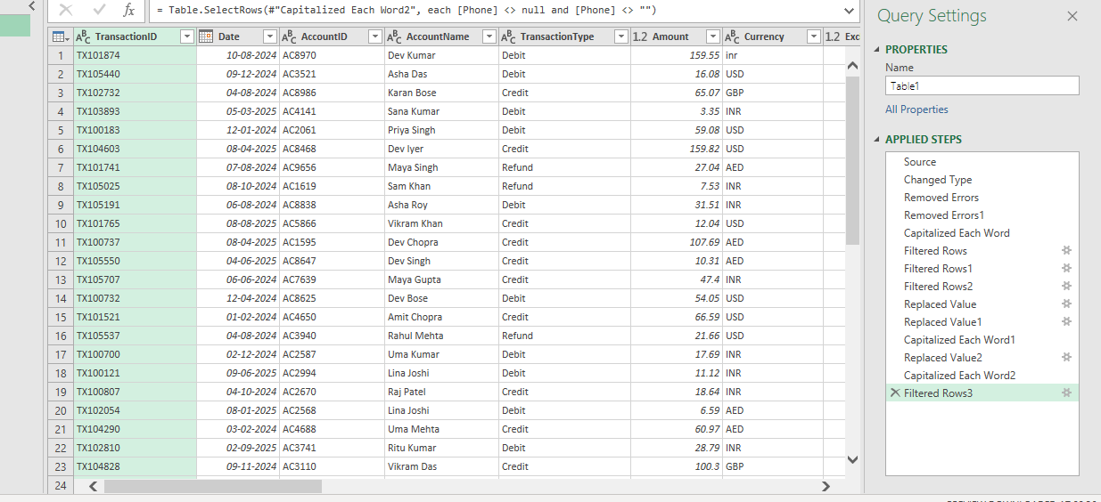
I have made replaced value in my dataset. And made group by and I filled with null values.
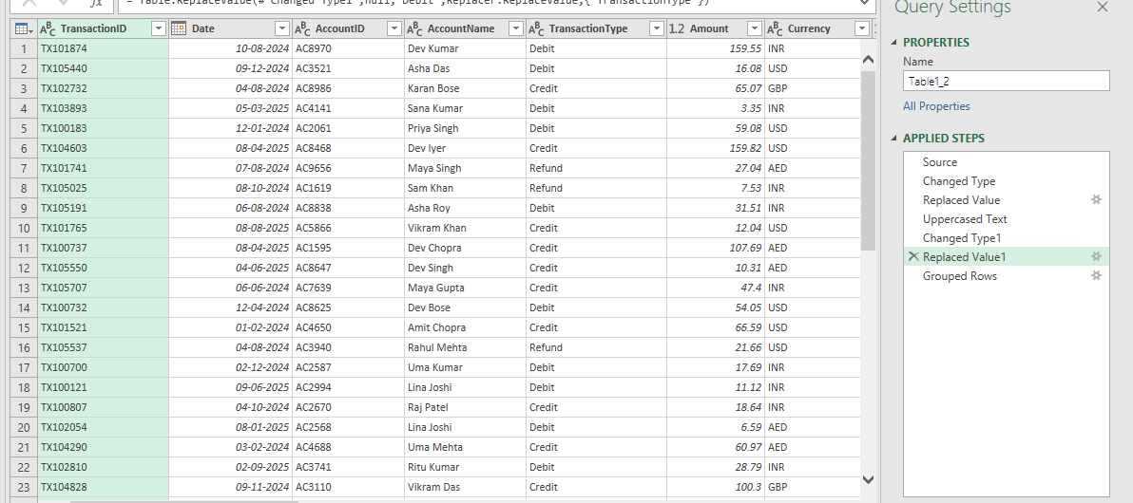

I Have made this chart using Quick analysis.
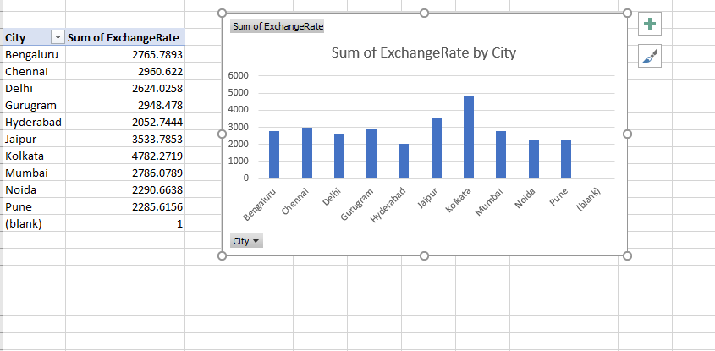

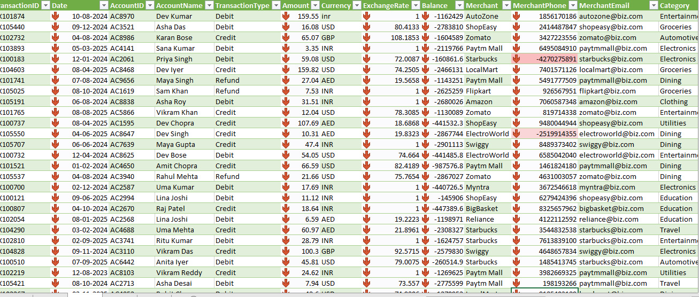
I have made conditional formatting.

I have made pivot table.
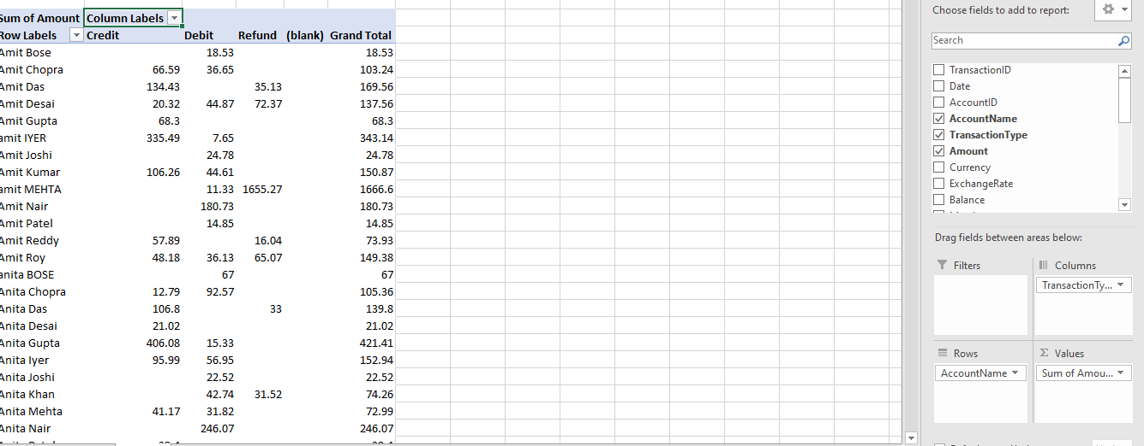

I have used descriptive statistics.

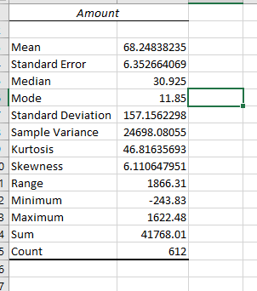

DATA VISUALIZATION

I have made column chart using category and account name.

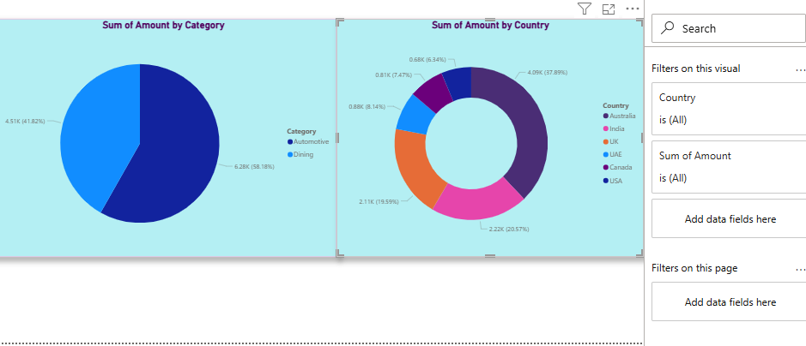
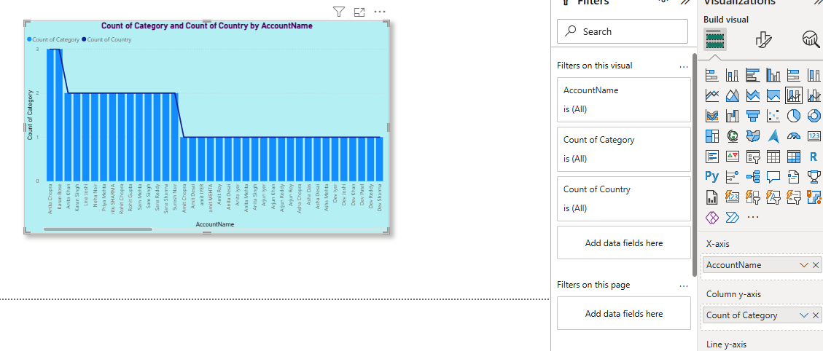
I have made sum of amount by category using pie chart and donut chart

I have made sum of amount using line chart.
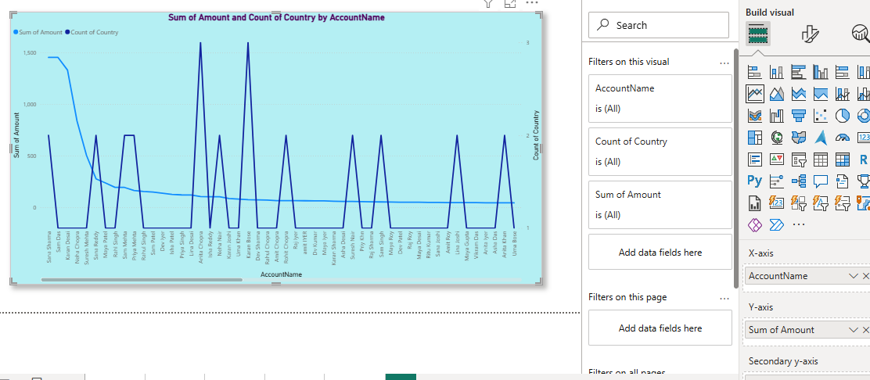

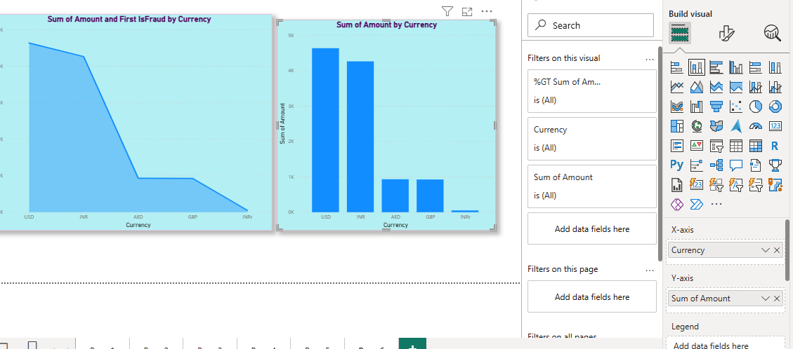
I have used area chart and column chart using currency

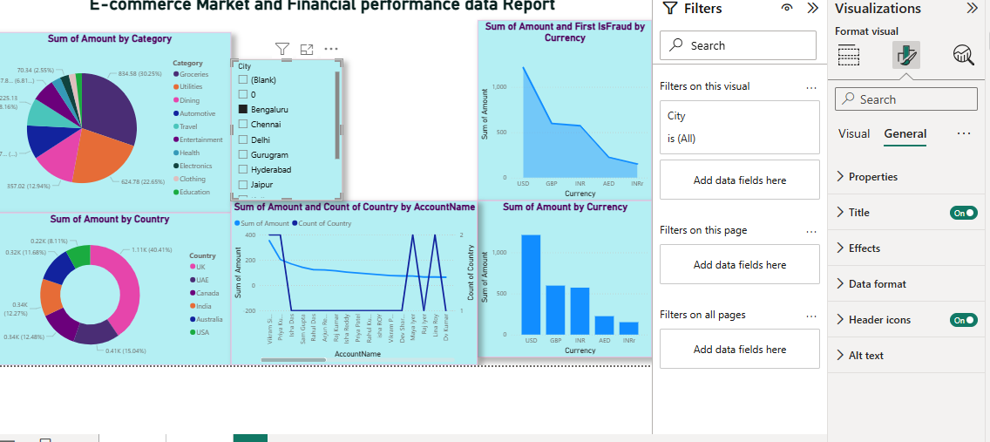
I have organised all the charts and made into a single report

I have used slicer make filter for the city Jaipur. And make filtering options

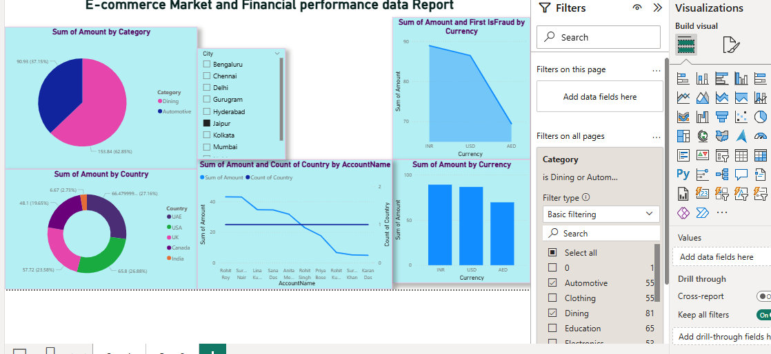
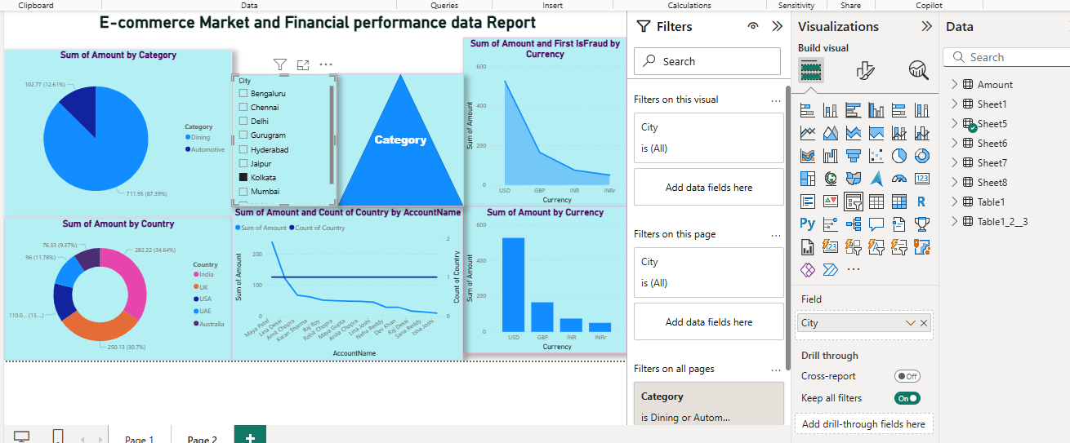
I have used buttons based on category.

Conclusion:
The E-Commerce Market and Financial performance data Dashboard provides insights into financial performance, calculating amount based on the category. This dashboard helps in monitoring trends, analyzing performance, and identifying areas of improvement.
By this we can we can get city wise performance and category we can easily able to identify which city has invested highest amount, providing insights into responsiveness.

